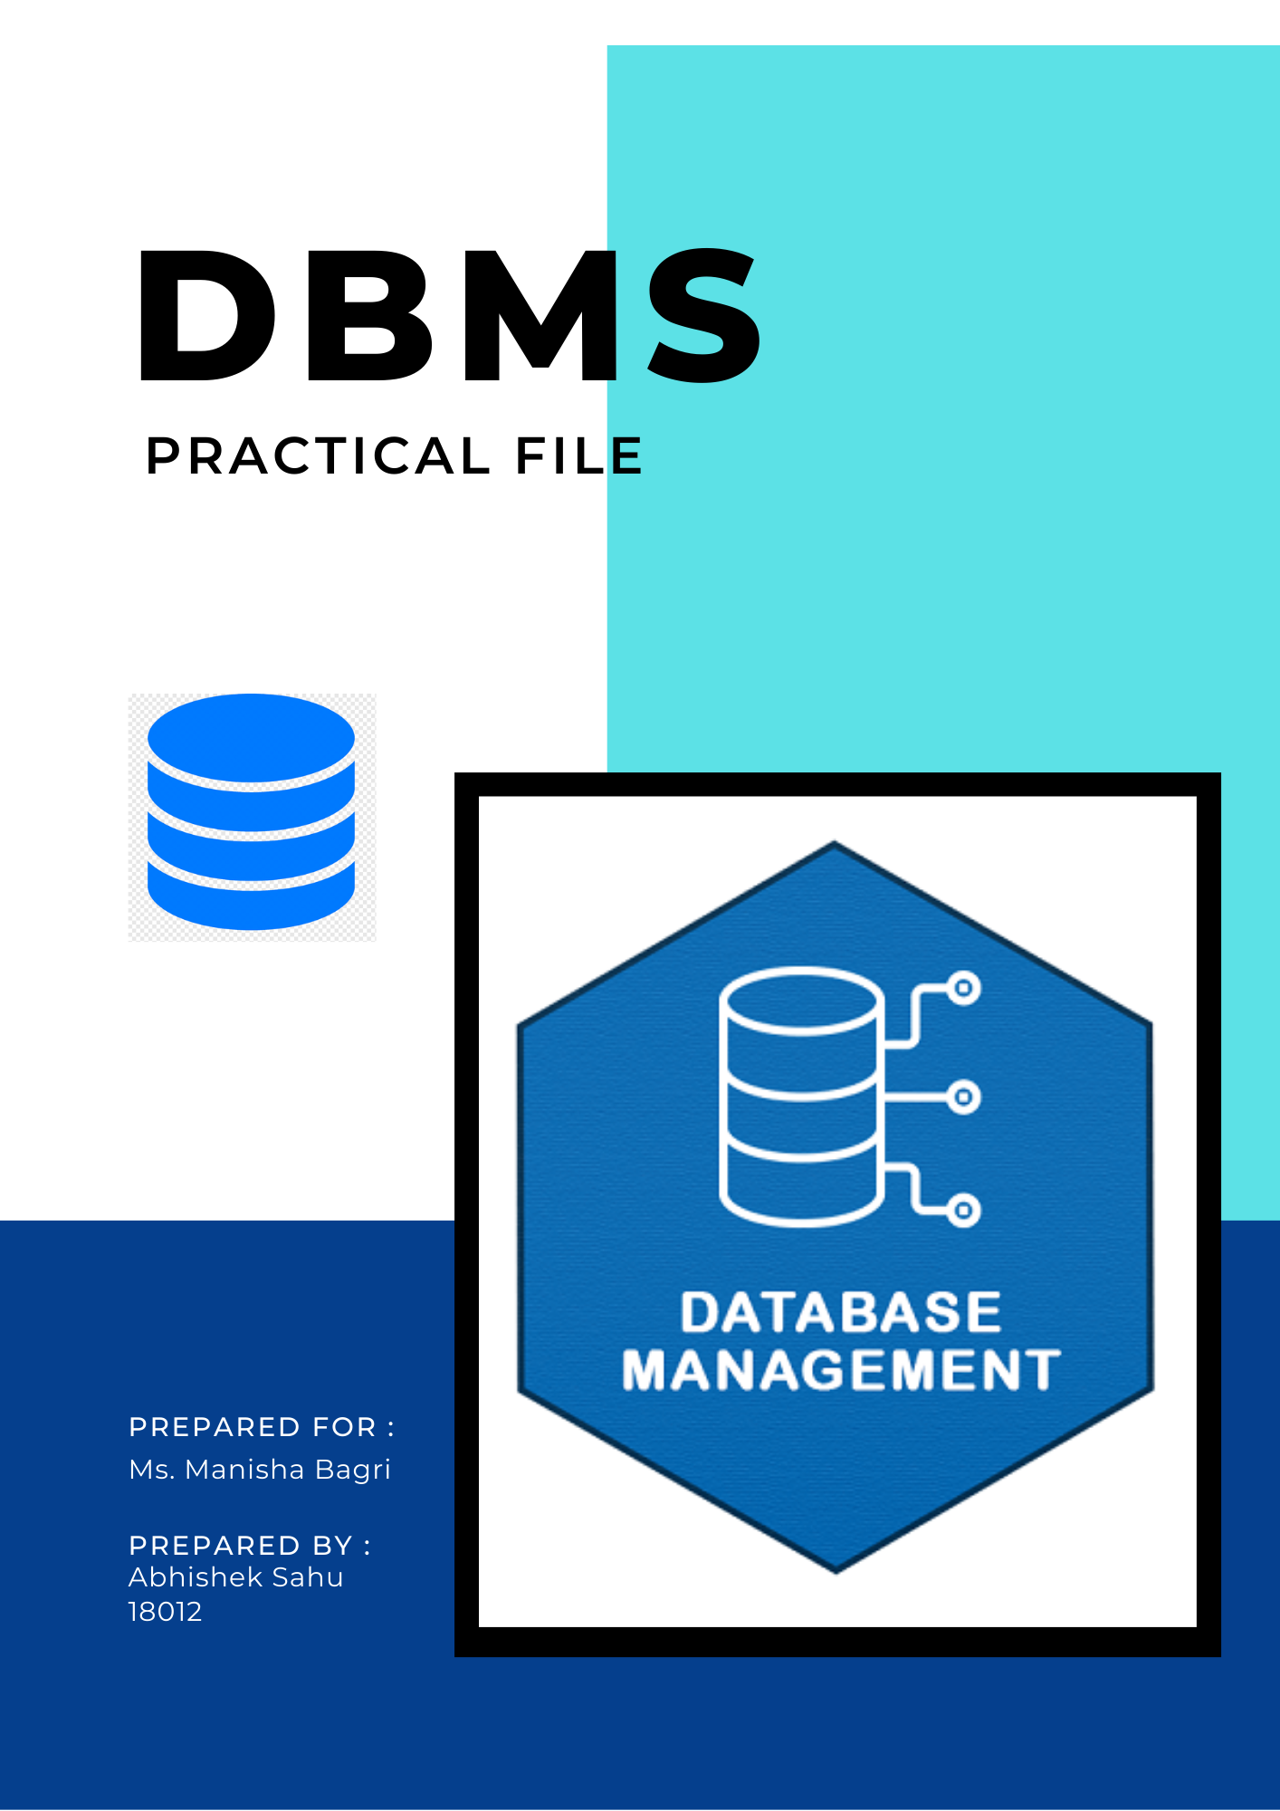

* **Creating EMPLOYEE-DEPARTMENT Schema:**

DROP SCHEMA IF EXISTS COMPANY;

CREATE SCHEMA COMPANY;

USE COMPANY;

CREATE TABLE EMPLOYEE

(

    Eno           CHAR(3)     NOT NULL,

    Ename         VARCHAR(50) NOT NULL,

    Job_type      VARCHAR(50) NOT NULL,

    SupervisorENo CHAR(3),

    Hire_date     DATE        NOT NULL,

    Dno           INT,

    Commission    DEC(10, 2),

    Salary        DEC(7, 2)   NOT NULL,

    PRIMARY KEY (Eno)

);

CREATE TABLE DEPARTMENT

(

    Dno      INT NOT NULL,

    Dname    VARCHAR(50),

    Location VARCHAR(50) DEFAULT 'New Delhi',

    PRIMARY KEY (Dno)

);

ALTER TABLE EMPLOYEE

    ADD CONSTRAINT SupervisorConstraint

        FOREIGN KEY (SupervisorENo) REFERENCES EMPLOYEE (Eno);

ALTER TABLE EMPLOYEE

    ADD CONSTRAINT DepartmentConstraint

        FOREIGN KEY (Dno) REFERENCES DEPARTMENT (Dno);

* **Adding data to tables:**

INSERT INTO DEPARTMENT

VALUES (10, 'Headquarters', 'Mumbai'),

       (45, 'Legal', 'Mumbai'),

       (30, 'IT', 'Bengaluru'),

       (20, 'Outreach', 'Dallas'),

       (95, 'Purchase', 'Dallas');

INSERT INTO DEPARTMENT (Dno, Dname)

VALUES (90, 'Sales'),

       (40, 'Administration'),

       (50, 'Research');

INSERT INTO EMPLOYEE

VALUES ('778', 'John Smith', 'Managing Director', NULL, '1980-06-12', 10, NULL, 5800.23),

       ('153', 'Andy Beaford', 'Manager', '778', '2000-09-08', 40, NULL, 502.30),

       ('23', 'Sudipto Ghosh', 'Manager', '778', '1981-11-21', 30, NULL, 2465.92),

       ('25', 'Anmol Gupta', 'Manager', '778', '1981-09-11', 40, NULL, 2865.92),

       ('86', 'Tania Chauhan', 'Manager', '778', '1983-08-14', 90, 235.90, 2921.37),

       ('89', 'Alicia Jones', 'Manager', '778', '1982-10-26', 95, NULL, 980.35),

       ('232', 'Isa Jaques', 'Manager', '778', '1996-07-23', 45, NULL, 651.05),

       ('520', 'King Hethron', 'Manager', '778', '2015-10-13', 90, NULL, 497.18),

       ('188', 'Sherline Harbord', 'Manager', '778', '1995-08-05', 40, NULL, 926.42),

       ('146', 'Donielle Tuite', 'Intern', '520', '2016-06-12', 90, NULL, 171.60),

       ('125', 'Gurpreet Singh', 'Intern', NULL, '2008-05-15', NULL, NULL, 521.37),

       ('243', 'Marie Brahms', 'Engineer', '23', '1983-06-22', 40, NULL, 876.78),

       ('299', 'Mahala Burtwhistle', 'Analyst', '89', '1990-07-20', 95, NULL, 602.86),

       ('354', 'Bryna McKenny', 'Analyst', '153', '2001-10-11', 90, NULL, 693.63),

       ('421', 'Ulberto Gosz', 'Assistant', NULL, '2017-02-07', 10, NULL, 381.64),

       ('442', 'Netti Dellenbrok', 'Designer', '23', '2014-05-14', 30, NULL, 790.82),

       ('492', 'Salmon Gough', 'Assistant', '86', '2008-12-13', 90, 148.80, 998.32),

       ('504', 'Berny Bonas', 'Accountant', '778', '2008-05-24', 40, NULL, 779.34),

       ('516', 'Lowell Paule', 'Systems Administrator', '23', '2008-03-31', 30, 324.39, 969.66),

       ('518', 'Nicholas Comelini', 'Accountant', '188', '1997-03-20', 90, 546.04, 882.53);

INSERT INTO EMPLOYEE

VALUES ('528', 'Laurence Grosvener', 'Intern', '520', '2019-09-06', 90, 125.45, 244.37),

       ('611', 'Brandtr Wildbore', 'Engineer', '23', '2000-04-14', 30, NULL, 704.23),

       ('697', 'Druci Sixsmith', 'Technician', NULL, '2005-07-27', 10, 530.53, 387.43),

       ('718', 'Oneida Hicklingbottom', 'Intern', '89', '2006-03-25', 95, NULL, 789.82),

       ('732', 'Gannie Quantrell', 'Architect', '23', '2019-04-29', 30, NULL, 174.12),

       ('783', 'Fran Lening', 'Analyst', '23', '1981-05-27', 30, NULL, 471.17),

       ('79', 'Rahul Sahay', 'Intern', '23', '2004-08-14', 30, NULL, 2921.37),

       ('811', 'Shay Restieaux', 'Lawyer', '232', '1999-04-16', 45, 574.68, 500.22),

       ('823', 'Marcille Occleshaw', 'Lawyer', '232', '2003-12-27', 45, 453.52, 507.10),

       ('832', 'Desiri Allott', 'Intern', '89', '1997-11-04', 95, 239.84, 683.09),

       ('87', 'Blake Lewis', 'Intern', '86', '2008-05-02', 90, 125.45, 244.37),

       ('908', 'Gustav Waring', 'Engineer', '23', '2002-12-23', 30, NULL, 141.05),

       ('960', 'Virge Swancott', 'Developer', '23', '1984-01-23', 30, NULL, 292.48),

       ('969', 'Lee Prattin', 'Developer', '23', '1986-01-23', 30, NULL, 296.48),

       ('997', 'Mag Giacomo', 'Architect', '23', '2002-12-23', 30, NULL, 427.98),

       ('785', 'Chandal McBrier', 'Consultant', '23', '1998-02-10', 30, NULL, 697.68),

       ('659', 'Martha Annies', 'Developer', '23', '2008-11-03', 30, NULL, 200.80),

       ('932', 'Selestina Herries', 'Engineer', '23', '2013-05-23', 30, NULL, 239.27),

       ('837', 'Ashil Burney', 'Engineer', '23', '1987-03-29', 30, NULL, 586.13);

INSERT INTO EMPLOYEE

VALUES ('763', 'Rodrick Haighton', 'Analyst', '23', '2000-05-08', 30, NULL, 627.74),

       ('981', 'Nina Fisby', 'Systems Administrator', '23', '2017-07-26', 30, 324.39, 920.84),

       ('498', 'Skell Woolerton', 'Engineer', '23', '2004-04-04', 30, NULL, 506.44),

       ('809', 'Cornie Munby', 'Consultant', '23', '1986-06-07', 30, NULL, 688.37),

       ('915', 'Layton Murrie', 'Designer', '23', '2006-06-24', 30, NULL, 640.31),

       ('842', 'Rivy Buzek', 'Technician', NULL, '1982-05-25', 30, NULL, 295.31);

**Queries :**

USE COMPANY;

-- EMPLOYEE

DESC EMPLOYEE;

-- DEPARTMENT

DESC DEPARTMENT;

-- Q1 Query to display Employee Name, Job, Hire Date, Employee Number; for each employee

with the Employee Number appearing first.

SELECT Eno,

       Ename,

       Job_type,

       Hire_date

FROM EMPLOYEE;

-- Q2 Query to display unique Jobs from the Employee Table.

SELECT DISTINCT Job_type

FROM EMPLOYEE;

-- Q3 Query to display the Employee Name concatenated by a Job separated by a comma

SELECT CONCAT(

               Ename, ',',

               Job_type

           ) AS Employee_Job

FROM EMPLOYEE;

-- Q4 Query to display all the data from the Employee Table. Separate each Column by a comma

--and name the said column as THE_OUTPUT.

SELECT CONCAT(

               Eno, ',',

               Ename, ',',

               Job_type, ',',

               IFNULL(SupervisorENo, ''), ',',

               Hire_date, ',',

               IFNULL(Dno, ''), ',',

               IFNULL(Commission, ''), ',',

               Salary

           ) AS THE_OUTPUT

FROM EMPLOYEE;

-- Q5Query to display the Employee Name and Salary of all the employees earning more than

--$2850.

SELECT Ename,

       Salary

FROM EMPLOYEE

WHERE Salary > 2850;

-- Q6 Query to display Employee Name and Department Number for the Employee No= 79.

SELECT Ename,

       Dno

FROM EMPLOYEE

WHERE Eno = '79';

-- Q7 Query to display Employee Name and Salary for all employees whose salary is not in the

--range of $1500 and $2850

SELECT Ename,

       Salary

FROM EMPLOYEE

WHERE Salary NOT BETWEEN 1500 AND 2850;

-- Q8 Query to display Employee Name and Department No. of all the employees in Dept 10 and

--Dept 30 in the alphabetical order by name

SELECT Ename,

       Dname

FROM (EMPLOYEE

         NATURAL JOIN DEPARTMENT)

WHERE Dno IN (10, 30)

ORDER BY Ename;

-- Q9 Query to display Name and Hire Date of every Employee who was hired in 1981

SELECT Ename,

       Hire_date

FROM EMPLOYEE

WHERE Hire_date

          LIKE '1981______';

-- Q10  Query to display Name and Job of all employees who have not assigned a supervisor.

SELECT Ename,

       Job_type

FROM EMPLOYEE

WHERE SupervisorENo IS NULL;

-- Q11 Query to display the Name, Salary and Commission for all the employees who earn

commission.

SELECT Ename,

       Salary,

       Commission

FROM EMPLOYEE

WHERE Commission IS NOT NULL;

-- Q12 Sort the data in descending order of Salary and Commission.

SELECT *

FROM EMPLOYEE

ORDER BY Salary DESC,

         Commission DESC;

-- Q13 Query to display Name of all the employees where the third letter of their name is ‘A’.

SELECT Ename

FROM EMPLOYEE

WHERE Ename LIKE '__A%';

-- Q14 Query to display Name of all employees either have two ‘R’s or have two ‘A’s in their

--name and are either in Dept No = 30 or their Manger’s Employee No = 7788.

SELECT Ename

FROM EMPLOYEE

WHERE Ename LIKE '%R%R%'

   OR Ename LIKE '%A%A%'

   OR Dno = 30

   OR SupervisorENo = '778';

-- Q15 Query to display Name, Salary and Commission for all employees whose Commission

--amount is greater than their Salary increased by 5%.

SELECT Ename,

       Salary,

       Commission

FROM EMPLOYEE

WHERE Commission > 1.05 * Salary;

-- Q16 Query to display the Current Date along with the day name.

SELECT DATE(NOW()),

       DAYNAME(NOW());

-- Q17  Query to display Name, Hire Date and Salary Review Date which is the 1st Monday after

--six months of employment.

WITH RECORDS(Ename, Hire_date, Six_after) AS (

    SELECT Ename,

           Hire_date,

           DATE_ADD(Hire_date, INTERVAL 6 MONTH)

               AS Six_after

    FROM EMPLOYEE

)

SELECT RECORDS.Ename,

       RECORDS.Hire_date,

       DATE_ADD(

               RECORDS.Six_after,

               INTERVAL

               IF(

                       0 = WEEKDAY(RECORDS.Six_after),

                       0 - WEEKDAY(RECORDS.Six_after),

                       7 - WEEKDAY(RECORDS.Six_after) + 0

                   )

               DAY

           ) AS Salary_review_date

FROM RECORDS;

-- Q18 Query to display Name and calculate the number of months between today and the date

--on which employee was hired of department ‘Purchase’.

SELECT Ename,

       TIMESTAMPDIFF(MONTH, Hire_date, NOW())

FROM (EMPLOYEE

         NATURAL JOIN DEPARTMENT)

WHERE Dname = 'Purchase';

-- Q19 Query to display Name and calculate the number of months between today and the date

--on which employee was hired of department ‘Purchase’.

SELECT CONCAT(

               Ename, ' earns $',

               Salary, ' monthly ',

               'but wants $', 3 * Salary

           )

           AS "Dream Salary"

FROM EMPLOYEE;

-- Q20 Query to display Name with the 1st letter capitalized and all other letter lower case and

--length of their name of all the employees whose name starts with ‘J’, ’A’ and ‘M’.

SELECT CONCAT(

               UPPER(SUBSTR(Ename, 1, 1)),

               LOWER(SUBSTR(Ename, 2))

           )

           AS "Name",

       LENGTH(Ename)

FROM EMPLOYEE

WHERE Ename LIKE 'J%'

   OR Ename LIKE 'A%'

   OR Ename LIKE 'M%';

-- Q21  Query to display Name, Hire Date and Day of the week on which the employee started.

SELECT Ename,

       Hire_date,

       DAYNAME(Hire_date)

FROM EMPLOYEE;

-- Q22 Query to display Name, Department Name and Department No for all the employees.

SELECT Ename,

       Dno,

       Dname

FROM (EMPLOYEE

         NATURAL JOIN DEPARTMENT);

-- Q23 Query to display Unique Listing of all Jobs that are in Department number 30.

SELECT DISTINCT Job_type

FROM EMPLOYEE

WHERE Dno = 30;

-- Q24 Query to display Name, Dept Name of all employees who have an ‘A’ in their name.

SELECT Ename,

       Dname

FROM (EMPLOYEE

         NATURAL JOIN DEPARTMENT)

WHERE Ename LIKE '%A%';

-- Q25  Query to display Name, Job, Department No. And Department Name for all the

--employees working at the Dallas location.

SELECT Ename,

       Job_type,

       Dno,

       Dname

FROM (EMPLOYEE

         NATURAL JOIN DEPARTMENT)

WHERE Location = 'Dallas';

-- Q26 uery to display Name and Employee no. Along with their supervisor’s Name and the

--supervisor’s employee no; along with the Employees’ Name who do not have a supervisor.

SELECT L.Ename,

SELECT E.Ename,

       E.Eno,

       S.Ename AS SupervisorName,

       S.Eno   AS SupervisorEno

FROM EMPLOYEE AS E

         LEFT OUTER JOIN EMPLOYEE AS S

                         ON E.SupervisorENo = S.Eno;

-- Q27 Query to display Name, Dept No. And Salary of any employee whose department No.

--and salary matches both the department no. And the salary of any employee who earns a

--commission.

SELECT L.Ename,

       L.Dno,

       L.Salary

FROM EMPLOYEE AS L,

     EMPLOYEE AS R

WHERE L.Dno = R.Dno

  AND L.Salary = R.Salary

  AND L.Eno <> R.Eno

  AND R.Commission IS NOT NULL;

-- Q28 Query to display Name and Salaries represented by asterisks, where each asterisk (*)

--signifies $100.

SELECT Ename,

       RPAD('*', Salary / 100, '*') AS Salary_Star

FROM EMPLOYEE;

-- Q29  Query to display the Highest, Lowest, Sum and Average Salaries of all the employees

SELECT MAX(Salary),

       MIN(Salary),

       SUM(Salary),

       AVG(Salary)

FROM EMPLOYEE;

-- Q30   Query to display the number of employees performing the same Job type functions.

SELECT Job_type,

       COUNT(DISTINCT Eno)

FROM EMPLOYEE

GROUP BY Job_type;

-- Q31  Query to display the total number of supervisors without listing their names.

SELECT COUNT(DISTINCT SupervisorENo)

FROM EMPLOYEE;

-- Q32 Query to display the Department Name, Location Name, No. of Employees and the

--average salary for all employees in that department.

SELECT Dname,

       Location,

       COUNT(*)              AS NumberOfEmployees,

       ROUND(AVG(Salary), 2) AS AvgSalary

FROM EMPLOYEE

         NATURAL JOIN DEPARTMENT

GROUP BY EMPLOYEE.Dno;

-- Q33  Query to display Name and Hire Date for all employees in the same dept. as Blake.

SELECT Ename,

       Hire_date

FROM EMPLOYEE

WHERE Dno IN (

    SELECT Dno

    FROM EMPLOYEE

    WHERE Ename LIKE 'Blake%'

);

-- Q34 Query to display the Employee No. And Name for all employees who earn more than the

average salary.

SELECT Ename,

       Salary

FROM EMPLOYEE

WHERE Salary > (

    SELECT AVG(Salary)

    FROM EMPLOYEE

);

-- Q35 Query to display Employee Number and Name for all employees who work in a

--department with any employee whose name contains a ‘T’.

SELECT Eno,

       Ename

FROM EMPLOYEE

WHERE Dno IN

      (

          SELECT Dno

          FROM EMPLOYEE

          WHERE Ename LIKE '%T%'

      );

-- Q36 Query to display the names and salaries of all employees who report to supervisor named

--‘King’

SELECT Ename,

       Salary

FROM EMPLOYEE

WHERE SupervisorENo IN (

    SELECT Eno

    FROM EMPLOYEE

    WHERE Ename LIKE 'King%'

);

-- Q37  Query to display the department no, name and job for all employees in the Sales

--department

SELECT Dno,

       Ename,

       Job_type

FROM (EMPLOYEE

         NATURAL JOIN DEPARTMENT)

WHERE Dname = 'Sales';

-- Q38 Display names of employees along with their department name who have more than 20

--years experience

SELECT Ename,

       Dname

FROM (EMPLOYEE

         NATURAL JOIN DEPARTMENT)

WHERE TIMESTAMPDIFF

          (

              YEAR,

              Hire_date,

              NOW()

          ) > 20;

-- Q39  Display total number of departments at each location

SELECT Location,

       COUNT(*)

FROM DEPARTMENT

GROUP BY Location;

-- Q40  Find the department name in which at least 20 employees work in

SELECT Dname

FROM (EMPLOYEE

         NATURAL JOIN DEPARTMENT)

GROUP BY Dno

HAVING COUNT(*) > 20;

-- Q41  Query to find the employee’ name who is not supervisor and name of supervisor

--supervising more than 5 employees.

(

    SELECT Ename

    FROM EMPLOYEE

    WHERE Eno NOT IN (

        SELECT DISTINCT SupervisorENo

        FROM EMPLOYEE

        WHERE SupervisorENo IS NOT NULL

    )

)

UNION

(

    SELECT Ename

    FROM EMPLOYEE

    WHERE Eno IN (

        SELECT SupervisorENo

        FROM EMPLOYEE

        WHERE SupervisorENo IS NOT NULL

        GROUP BY SupervisorENo

        HAVING COUNT(*) > 5

    )

);

-- Q42 Query to display the job type with maximum and minimum employees

WITH JOBCOUNT AS (

    SELECT COUNT(*) AS ECount

    FROM EMPLOYEE

    GROUP BY Job_type

)

SELECT Job_type,

       COUNT(*)

FROM EMPLOYEE

GROUP BY Job_type

HAVING COUNT(*) IN (

    (

        SELECT MAX(ECount)

        FROM JOBCOUNT

    )

    UNION

    (

        SELECT MIN(ECount)

        FROM JOBCOUNT

    )

);

**OUTPUT:**

====

Q1

====

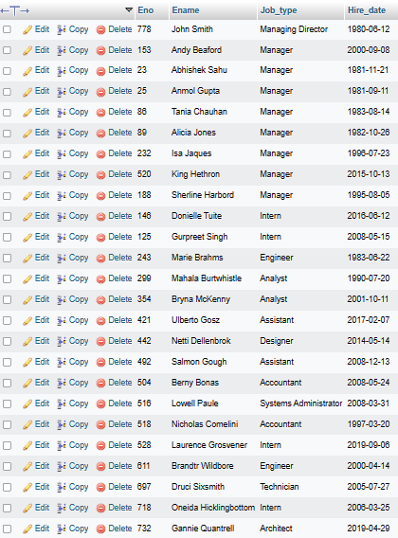

====

Q2

====

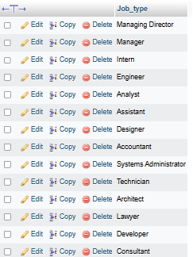

====

Q3

====

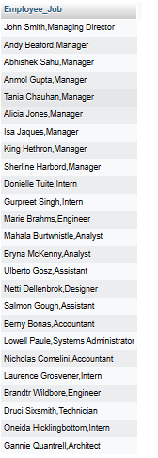

====

Q4

====

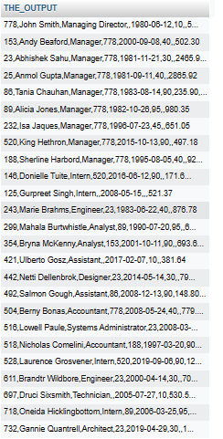

====

Q5

====

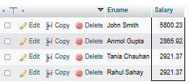

====

Q6

====



====

Q7

====

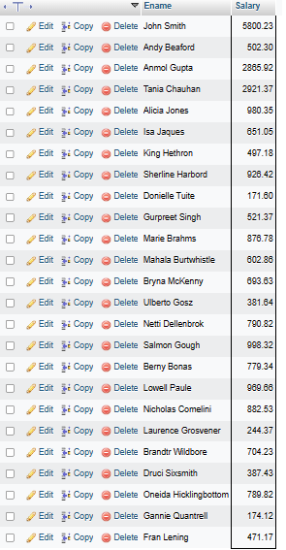

====

Q8

====

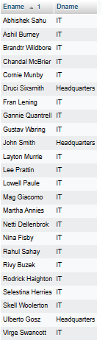

====

Q9

====

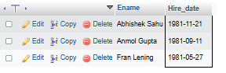

=====

Q10

=====

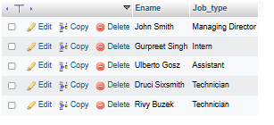

=====

Q11

=====

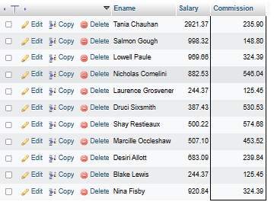

=====

Q12

=====

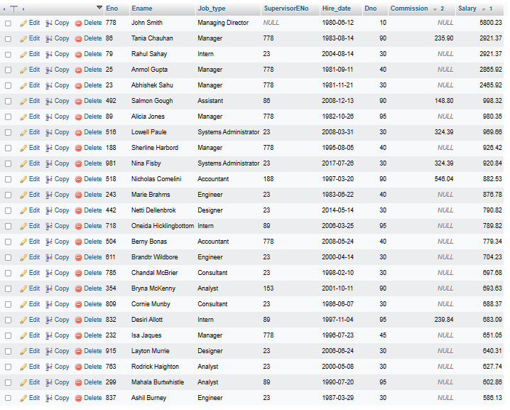

=====

Q13

=====

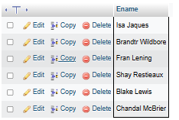

=====

Q14

=====

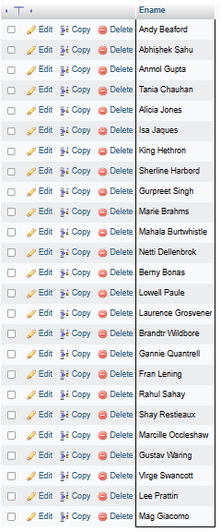

=====

Q15

=====

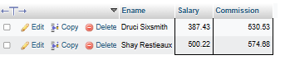

=====

Q16

=====



=====

Q17

=====

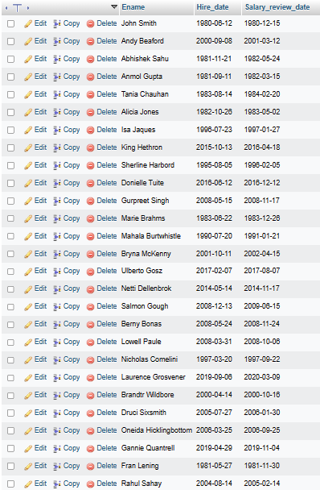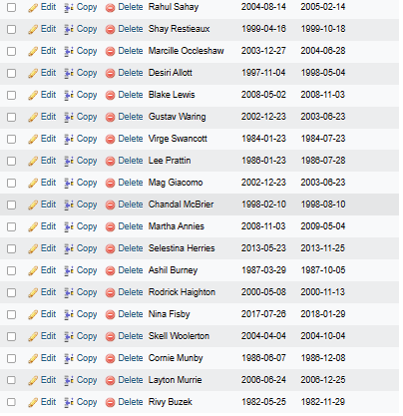

=====

Q18

=====

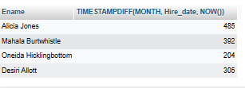

=====

Q19

=====

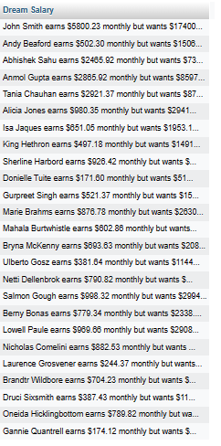

=====

Q20

=====

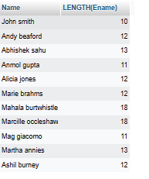

=====

Q21

=====

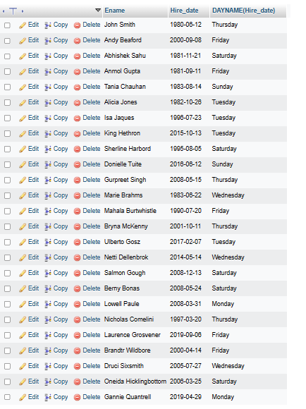

=====

Q22

=====

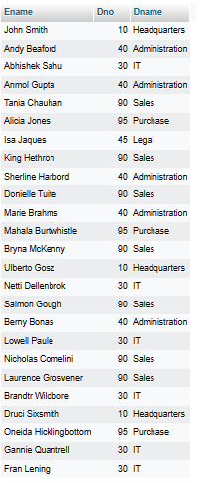

=====

Q23

=====

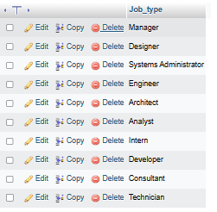

=====

Q24

=====

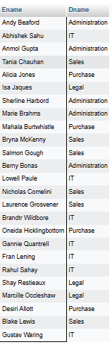

=====

Q25

=====

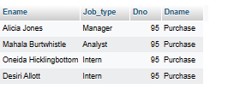

=====

Q26

=====

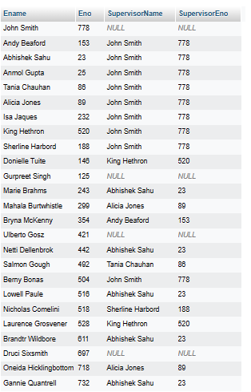

=====

Q27

=====

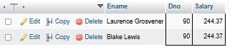

=====

Q28

=====

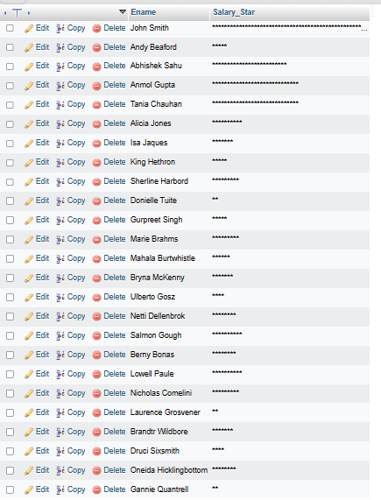

=====

Q29

=====



=====

Q30

=====

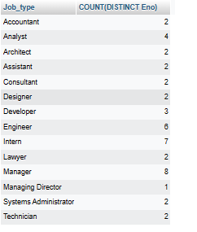

=====

Q31

=====



=====

Q32

=====

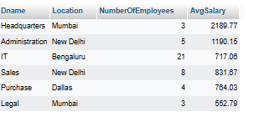

=====

Q33

=====

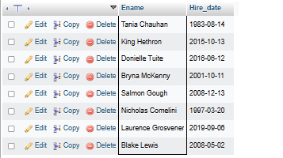

=====

Q34

=====

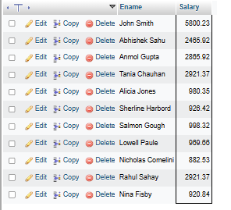

=====

Q35

=====

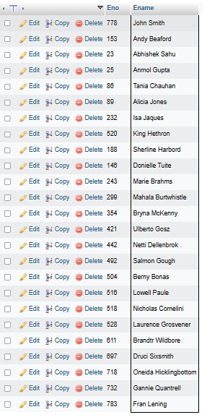

=====

Q36

=====



=====

Q37

=====

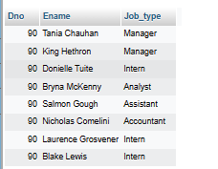

=====

Q38

=====

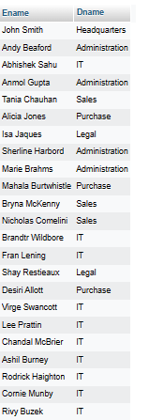

=====

Q39

=====

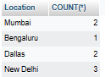

=====

Q40

=====



=====

Q41

=====

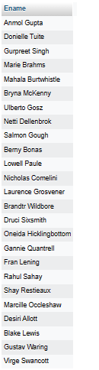

=====

Q42

=====

